Atlantic City Waterfront Revitalization

Fall 2025
Environmental Design Studio 11:550:331
Rutgers University School of Environmental and Biological Sciences
Instructors: Dr. Frank Gallagher & Haemee Han

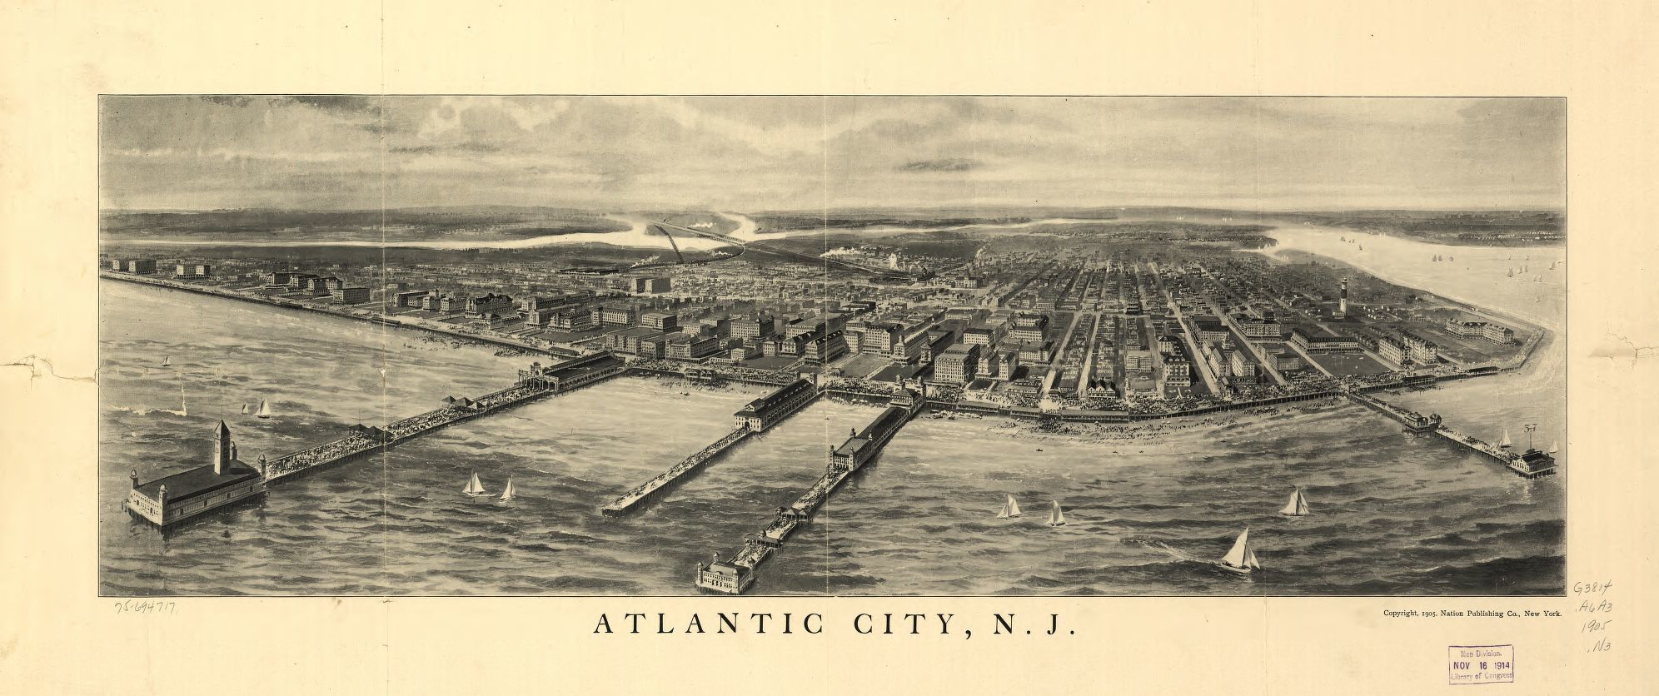

Overview

Utopian Playground

From the grand amusement parks of Coney Island to the highly curated environments of Disneyland, utopian thinking has long influenced the design and origins of artificial paradises. While not direct extensions of a utopian city framework, these spaces reflect a desire to separate leisure from industrialization and urban life, aligning with models like Ebenezer Howard’s Garden City, these places focus on providing respite from work and offering optimized rest, recreation, and well-being. They also view the surrounding environment as a recreational asset rather than the community to which we all belong.

Atlantic City was once envisioned within this lineage-a purpose-built resort city where visitors could enjoy the restorative effects of the ocean and the pleasures of a carefully curated environment.

Once known as “America’s Playground,” Atlantic City is now a city of contradictions-both a spectacle of grand casino developments and a landscape of abandonment, vacancy, and economic disparity. Following World War II, the rise of automobile culture diminished the city’s reliance on rail-based tourism, leading to an economic downturn. The legalization of gambling in 1976 was a desperate attempt at revitalization, resulting in a rapid influx of casinos and hotels. While this development initially generated economic growth, it was neither sustainable nor equitable.

Atlantic City today presents an extreme case of the contemporary urban condition—one where large-scale developments coexist with vacant lots, where the scale of architecture alienates rather than invites, and where economic fluctuations dictate the city’s fate. As it struggles to revitalize, Atlantic City faces critical challenges that threaten its future viability.

Key Challenges of Atlantic City

Environmental Vulnerabilities and Climate Change
As a coastal city, Atlantic City faces increasing threats from rising sea levels and extreme weather events. Hurricane Sandy in 2012 exposed the vulnerabilities of its built environment, prompting various infrastructural responses, yet much of the city remains at risk. In addition, the city built of concrete and macadam with little green space experiences a heat Island effect that can raise the ambient maximum and minimum summer temperatures by more than 3º C. Heat Islands have also been shown to increase rainfall intensity further exacerbating event flooding. What landscape manipulation can be implemented to both reduce the risk posed by climate change and enhance the quality of life for the community?

The Identity Crisis: Abandonment, Vacancy, and the Ghost City Effect
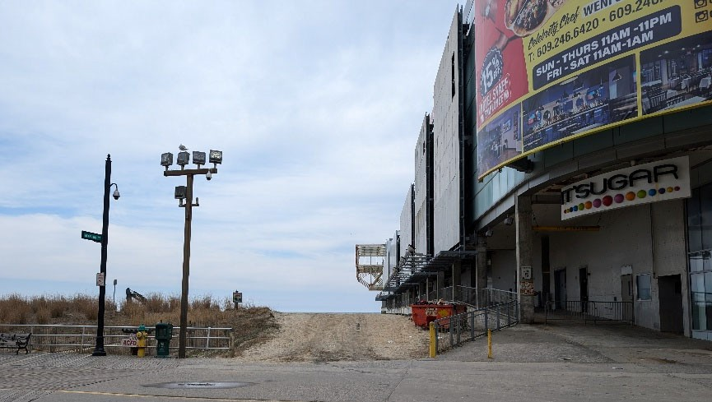
Many of Atlantic City’s casinos have shuttered, leaving behind vacant megastructures-some imploded, others standing as remnants of failed economic experiments. The city’s identity oscillates between spectacle and desolation. Can such a site be redeveloped through the lenses of both ecological sustainability and social justice?

ACX1 Studio (formerly Playground Pier), considered as “dead mall”

Lack of Human Scale and underutilized Megastructures
Casino developments occupy massive blocks, creating negative, inaccessible spaces between them. The existing urban grid is disrupted by these monolithic structures, leading to dead zones, disconnected pedestrian experiences, and inhospitable public spaces. How can design interventions reclaim the human scale in an environment dominated by overscaled, underutilized structures?

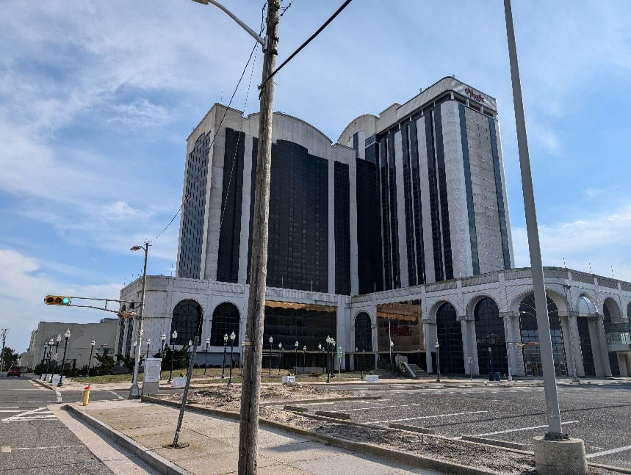
Vacant, abandoned Casino, Atlantic Club

Limited Water Access
Despite being a coastal city, Atlantic City is heavily relied on automobiles. Pacific Avenue, running parallel to the Boardwalk, serves as a service corridor rather than a public space, rendering the backside of casinos inactive and unsafe. The Boardwalk itself, though iconic, is often an underutilized vast wooden expanse lacking programming that fosters human interaction beyond seasonal tourism.
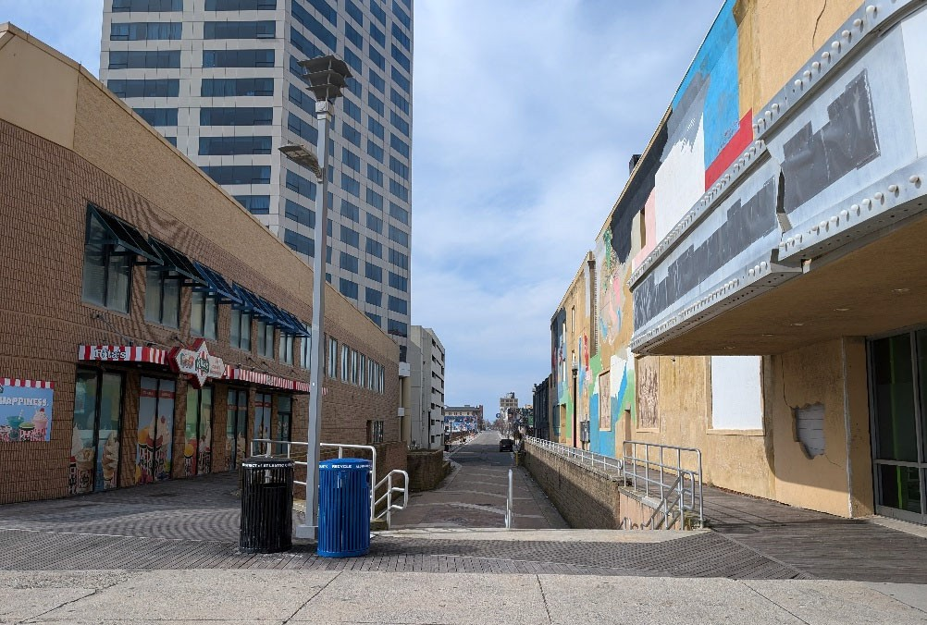
Access point from Pacific ave to Boardwalk

Rethinking Tourism: From Seasonal Economy to Sustainable City
With competing entertainment hubs emerging in neighboring states, Atlantic City’s reliance on casino-based tourism is no longer viable. What alternative urban models can ensure economic and environmental sustainability? How can new programmatic interventions balance tourism with community well-being?

Ongoing Redevelopment Efforts
Atlantic City is undergoing significant redevelopment beyond the Boardwalk. The recently opened Ocean Casino ( formerly Revel ) marks a major investment in revitalization. Additionally, the city has announced a $3 billion development plan for Bader Field, which is progressing rapidly. Other key renewal sites include the Atlantic Avenue Corridor, Gateway Redevelopment, and Steel Pier Redevelopment Area, all of which are part of the city's ongoing transformation efforts.
How can the new urban design frame work respond to the on going redevelopment plan ?
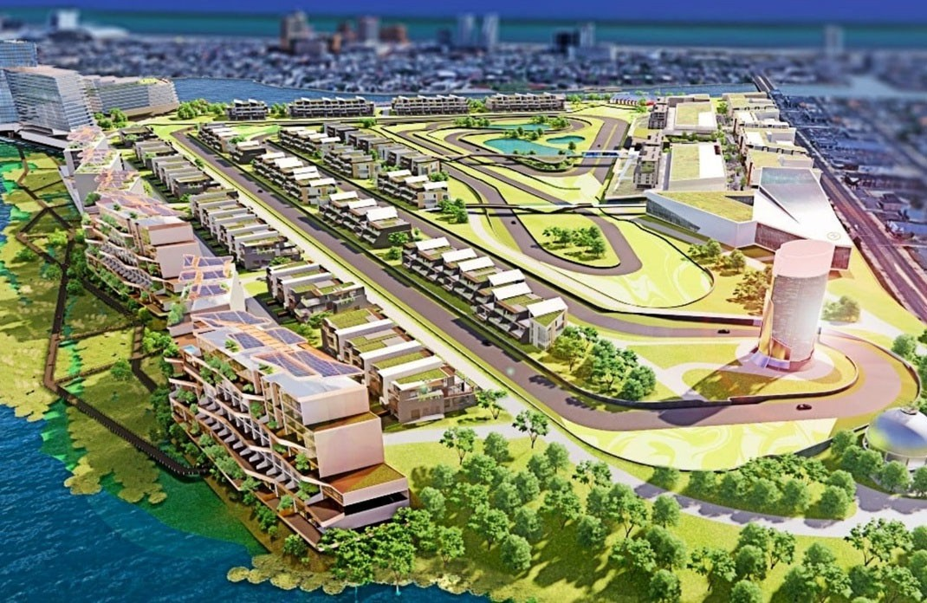
3 billion on going development project at Bader Field, including racetrack, mixed use community

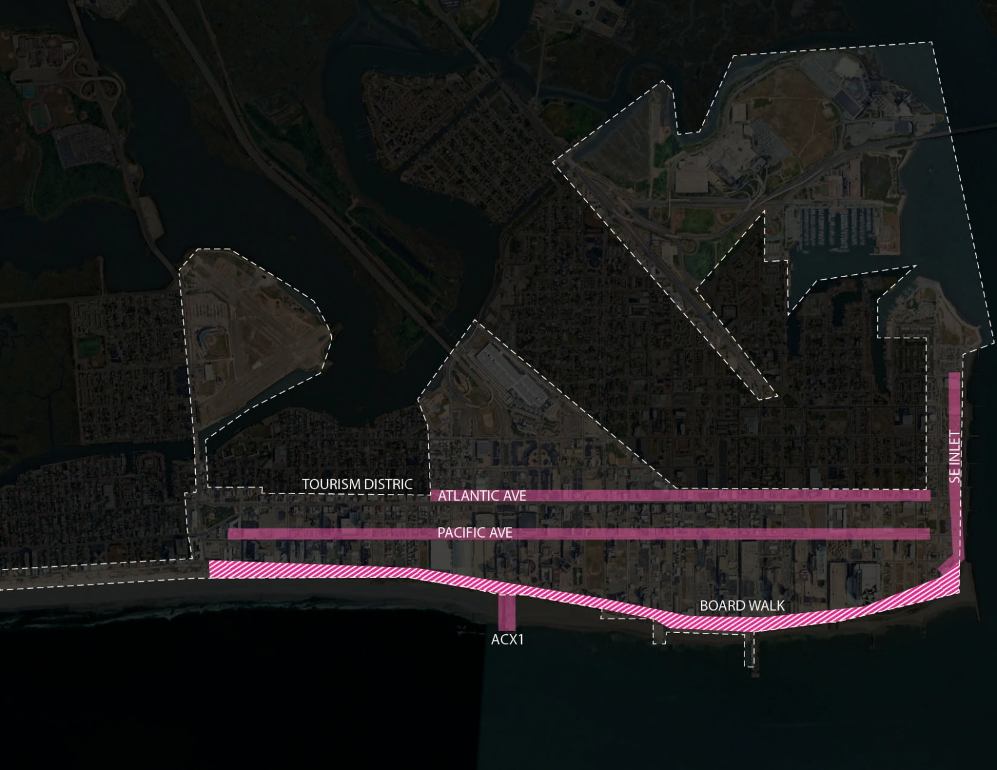

Studio Focus

Students will explore the potential of landscape architecture to transform Atlantic City’s waterfront into a prototype for the next urban utopia.

This course will challenge students to think beyond conventional urban redevelopment models and instead engage with the speculative futures resulting from climate change, radical design methods that considers alternate energy and ecosystem services, and experimental urban strategies. By questioning the fundamental principles of urbanism, students will reimagine Atlantic City not as a relic of the past but as a site for innovation, resilience, and transformative site.
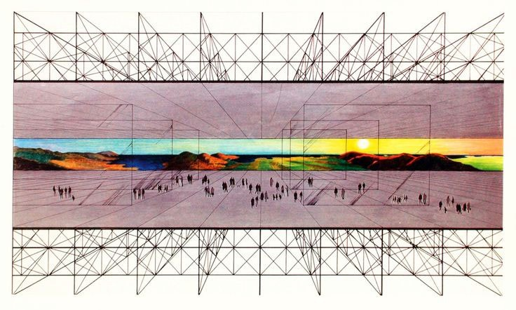
Archizoom, No-Stop-City, 1970

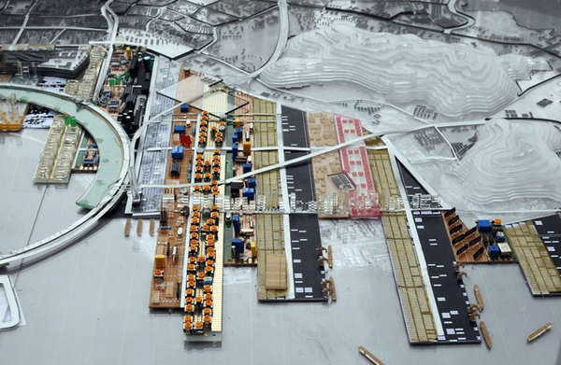
OMA, Qianhai, Port City, 2010

Design Methods

1. New Urban Framework

Each student will develop an urban system addressing one or more of the city's challenges. Can new urban systems respond to rising sea levels, storms, and changing ecosystems?
What would Atlantic City be without gambling? Can new economic models redefine its identity? How can vacancy be an opportunity rather than a failure? Can ghost structures become hosts for new life? Can new programs become physical forms that attach / intersect onto failing structures in ways that transform their meaning? Could the Boardwalk be more than just a tourist attraction? What if it became a hybrid ecological and social system? How can playground co-exist with everyday life?
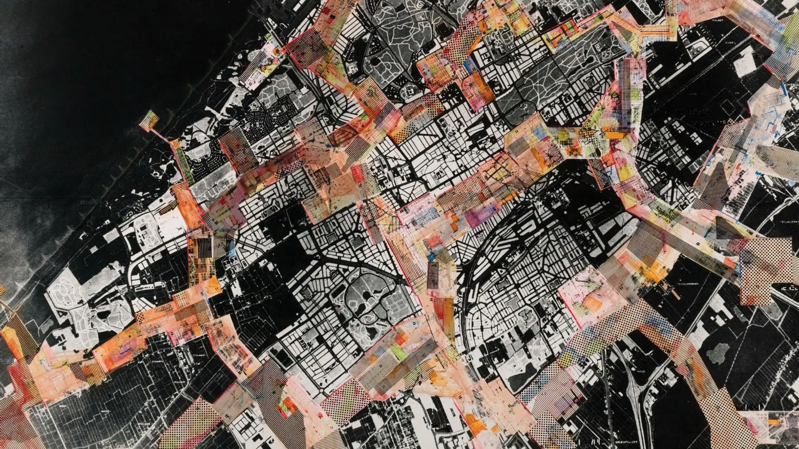
Constant Nieuwenhuys, New Babylon, 1959

2. Developing Intervention Catalogue

In this phase, students will design interventions that respond directly to the physical, social, and ecological conditions of Atlantic City. Drawing from their urban frameworks, each student will propose a series of strategic, site-specific actions that address the city’s challenges.

These interventions will take on adaptable formats that can respond to various urban conditions within Atlantic City, offering a spectrum of approaches that range in scale, duration, and intensity. The outcome of this phase is a set of thoughtful, well-grounded intervention strategies—each a creative response to Atlantic City’s conditions, and a contribution to a broader vision for a more adaptive, inclusive, and resilient urban landscape.

Possible approaches include, but not limited to:
- Urban Infill
- Parasite
- Temporal (Short term)
- Permanent (Long term)
- Edge Conditions
- Reprogramming
- Connective System

Students will develop their ideas through drawings, diagrams, physical studies, and simple modeling techniques. While full-scale prototyping is not the emphasis, small mock-ups or material tests may be used to explore spatial or experiential qualities.


MVRDV, Rooftop Catalogue, 2020
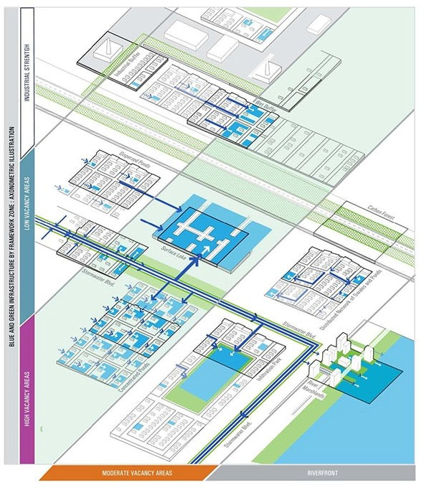
Stoss, Detroit Future City, 2013

3. Masterplan (Site Design)

Building on the modules and systems developed in the previous phase, students will now move into site-specific design. Each student will craft an overall site plan and focus on four key areas that serve as anchors of their design concept. These areas should express the core ideas of the intervention strategies and demonstrate how the proposed systems perform spatially, socially, and ecologically.

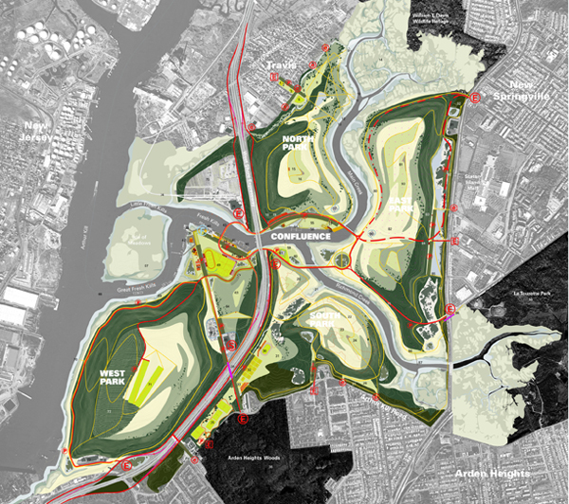
Field Operations, Fresh Kills

4. Future Scenarios

Students will explore possible future scenarios for Atlantic City, imagining how the city might evolve under shifting environmental, economic, and social conditions. These scenarios may respond to sea level rise, intensified storms, population shifts, tourism decline or resurgence, technological change, or new models of governance and care.

This phase asks students to design with time—considering how their interventions unfold across short-, medium-, and long-term horizons. What happens immediately after implementation? What changes emerge five, ten, or twenty years later? By phasing their proposals, students will test how space transforms and how communities might adapt alongside it.

Using drawings, timelines, mappings, and layered narratives, students will simulate the aftereffects of design-not just as objects in space, but as agents of ecological recovery, social interaction, and urban change.

This final phase serves as both reflection and projection. It challenges students to situate their interventions within larger temporal and systemic dynamics, offering not only a spatial solution, but a vision for how design might guide Atlantic City toward a more adaptive, inclusive, and resilient future.
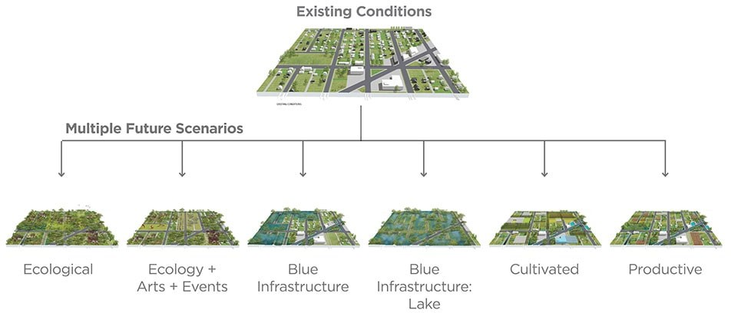

Stoss, Detroit Future City, 2013

Course Objectives

  - Develop new urban systems that address economic, environmental, and social issues, exploring solutions beyond traditional tourism-based models.
  - Investigate how to repurpose vacant spaces and abandoned structures, turning them into assets.
  - Explore new landscapes and other urban interventions to revitalize the city's existing fabric and transform decaying megastructures.
  - Design long-term, sustainable urban strategies that respond to higher temperatures, rising sea levels, and extreme weather events, creating resilient systems.
  - Reimagine existing infrastructures as a multifunctional, hybrid ecological and social space, balancing tourism with community needs.
  - Use both digital and physical modeling techniques to develop, test, and prototype design concepts at various scales, from small interventions to large urban systems.
  - Critical thinking and speculative design methods to propose radical urban transformations that challenge conventional redevelopment practices.
  - Explore the role of time in urban design through temporary interventions, permanent urban strategies and phased approaches that adapt to shifting economic and environmental conditions.
  - Create a transformative vision for Atlantic City that redefines its identity and potential as a model for sustainable city in the 21st century.

Assignment Focus

Assignment 1: My Neighborhood, My Utopia (Analytical Diagram + Concept Generating) – 1 week
*Assignment 2: Case Study (Precedent Analysis) – 2 weeks
*Project Phase 1: Inventory & Analysis (Mapping and Framing Issues) – 2 weeks
*Project Phase 2: Concept & Urban Framework
(Generating Urban Concepts and Developing Strategies) – 2 weeks
*Project Phase 3: Intervention Catalogue (Adaptable Landscape Systems) – 2 weeks
*Project Phase 4: Masterplan (Site Design in Different scales) – 3 weeks
*Project Phase 5: Future Scenario & Final Design (Phasing and Speculation) – 2 weeks

* Indicates Group Project

Course Schedule

WK | DAY | ACTIVITY | ASSIGNMENT | SUGGESTED READINGS
1 | 9/2 | Why? (FG)  Course Overview (HH)  Analytical Diagram (FG)  Utopia (HH) | A.01  My Neighborhood Project | A Sense of Place (Stegner)
1 | 9/4 | What is a “Landscapist Attitude”  in Design? (FG)
2 | 9/9 | Assignment 1 Discussion  Case Study Intro  (FG, HH) | A.01 Due  A.02 : Case Study
2 | 9/11 | Urbanism (HH) |  | New Urbanism: Past, Present,  and Future (Garde)
3 | 9/16 | Native vs Non-Native  “Context” (FG) |  | Ecological Design or  Designer Ecology
3 | 9/18 | Assignment 2 Discussion | A.02 Due
4 | 9/23 | Inventory Analysis (FG+HH) | P.01  :Inventory and Analysis | Novel ecosystems: implications for conservation and restoration
4 | 9/25 | Potential Site Visit
5 | 9/30 | Native vs Non-Native  “Context” (FG)
5 | 10/2 | Project 1 Discussion | P.01 Due | What is Good Ecological  Restoration
6 | 10/7 | Urban Framework (HH)  Design Group Formation | P.02 :Urban Framework | Delirious New York, Coney Island  (Koolhaas)
6 | 10/9 | Urban Blocks + Density (HH) |  | Chance Design for  Ecological Democracy
7 | 10/14 | Work Session
7 | 10/16 | Project 2 Discussion  Intervention Catalogue (HH) | P.02 Due  P.03 :Intervention Catalogue | Ecosystem Service
8 | 10/21 | Work Session |  | The Tourist Gaze (Urry)
8 | 10/23 | HH Out –zoom per request
9 | 10/28 | Work Session |  | Public Trust Doctrine
9 | 10/30 | Project 3 Discussion  Masterplan Intro (FG+HH) | P.03 Due  P.04 :Masterplan
10 | 11/4 | Design Narrative (HH)
10 | 11/6 | Pin Up
11 | 11/11 | Diagrams (HH)
11 | 11/13 | Work Session
12 | 11/18 | Work Session
12 | 11/20 | Mid Review | P.04 Due  Midterm Review
13 | 11/25 | Mid Review Recap  Intro to Final Deliverable  (FG+HH) | P.05 :Future Scenario | Terra Fluxus (Corner)
13 | 11/27 | Thanksgiving Day
14 | 12/2 | Work Session
14 | 12/4 | Work Session
15 | 12/9 | Pin Up | Last Day of Class
15 | 12/11 | Reading Day | Additional Desk Crit per request
16 | 12/18 | Final Presentation date TBD | P.05 Due Final Review

*The schedule above is tentative and may change as the course develops. A detailed schedule with Individual assignments are found on the course website.

Grading

You will be graded based on your achievement of the learning objectives for the course through the completion of course assignments and active participation in course activities. Deliverables and evaluation criteria for specific exercises will be provided prior to the exercise. The studio will employ a variety of techniques and exercises over the semester, and grading techniques will vary with each assignment.

Assignment 1: My Neighborhood, My Utopia – 5%
Assignment 2: Case Study– 5%
Project Phase 1: Inventory & Analysis – 10%
Project Phase 2: Concept & Urban Framework – 15%
Project Phase 3: Intervention Catalogue – 15%
Project Phase 4: Masterplan – 20%
Project Phase 5: Future Scenario & Final Design – 30%

Field Trips

Site visit to Atlantic City is required for the course.

Reviews

You will have two reviews over the course of the semester where you will be asked to formally present your work to reviewers, including external guest critics as well as your instructors.
We will try to limit these reviews to normal class hours, please keep in mind that presentations by the entire class can be time intensive and we will need to work around the schedules of guest critics. Reviews may start before normal class hours or end after, do what you can to schedule accordingly. Please let us know immediately of any schedule conflicts that arise over the course of the semester.

Studio Resources

Course readings will be made available on the course Canvas website. Data and information such as base maps and the environmental impact statement will be available through the course folder. However, students are highly recommended to search for and gather the data they need to support their research independently.
Canvas has difficulty with large files a course folder has been established on Rutgers OneDrive.
This studio will require all the basic drawing, drafting and modeling techniques that you have employed in prior studios. Individual assignments may require you to purchase specific materials depending on the approach you choose to take in developing your design. For all studio meetings, you should be prepared with the following at your desk:
Trace paper for sketching and diagramming; you should always have a roll of 12” trace at your desk, and large sizes as is required by the size of your drawings.

Computer and Software

In addition to analog materials, this studio will require you to utilize the computer for research, analysis, and representation. You should utilize your own computer or use the school's computers available in the computer lab when necessary. Students are highly recommended to be familiar with and have access to the following programs:

Midjourney *
The Adobe Design Suite
Microsoft Office (Excel, Word)
ArcGIS Pro
AutoCAD
Rhinoceros 3D
Lumion

Recommended Readings

Delirious New York: A Retroactive Manifesto for Manhattan by Rem Koolhaas. The Monacelli Press, 1994

The Tourist Gaze. By John Urry. London; Sage Publications. 1990.

Terra Fluxus in the landscape urbanism reader, by James Corner edited by Charles Waldheim, 21-33. New York: Princeton Architectural Press, 2006

Utopia. By Thomas More Cambridge University Press, 2002.

Learning from Las Vegas by Robert Venturi, Denise Scott Brown, and Steven Izenour. MIT Press, 1972.

Additional Resources

Ana I Baptista, “Finding Hope at the Margins: A Journey of Environmental Justice.” Ecological
and Social Healing: Multicultural Women’s Voices. Ed. Jeanine M. Canty. NY: Routledge, 2017.

Isabelle Anguelovski. (2016). “From Toxic Sites to Parks as (Green) LULUs? New Challenges of
Inequity, Privilege, Gentrification, and Exclusion for Urban Environmental Justice.” JPL.

.

Reference

Bloustein School of Planning and Public Policy. (2014). Turning the tide: Atlantic City waterfront access & revitalization plan report. Rutgers University.

New Jersey Economic Development Authority. (2021). Atlantic City Restart and Recovery Working Group Report.

New Jersey Economic Development Authority. (n.d.). Atlantic City revitalization grant program. https://www.njeda.gov/atlantic-city-revitalization-grant-program-phase-two/

Wild Innovation : Stoss in Detroit (2013). By Jill Desmini https://scenariojournal.com/article/wild-innovation/

Course Format

- Lecture / Presentations
- Readings/ Discussion
- In-Class Exercises
- Desk Crits
- Site Visit
- Mid Review & Final Review

Student Obligations and expectations

The course is required in both the Environmental Planning and Landscape Architecture degree programs and the second in the sequence of Visualization courses required by the student for graduation. In accordance with university policy, students are expected to work an additional 9.75 hours per week outside of class. Therefore, please prepare appropriate time in your schedule this semester in relationship to your other course work, employment, and social obligations to prepare for and participate in class.

Students are expected to:
- Complete and submit all assignments as directed on the designated due date. Late coursework will not be accepted.
- Come to class on time. Late arrivals greater than ten (10) minutes will be marked as absence.
- Take notes during class presentations to help retain knowledge and repeat procedures outside of class. The instructor will not review any content that has been missed by a student’s absence. Your attendance will be directly related to your success in this class.
- Care. Put 100% into every one of your assignments and be proud of the work you produce in this class. Treat each assignment like it is your last.
- Seek help, when needed, during office hours and in advance of an assignment’s due date.

Departmental Grading Guidelines

While the assignment of grades is ultimately the purview of the instructor, the department uses the following guidelines for understanding appropriate grading in its courses:

- Outstanding -This not only means fulfilling the requirements but impressing and going beyond the initial expectations of the project. The student has demonstrated a superior grasp of the subject matter coupled with a high degree of creative or logical expression, and strong ability to present these ideas in an organized and analytical manner,

- Very Good - The student has demonstrated a solid grasp of the material with an ability to organize and examine the material in an organized, critical, and constructive manner, The projects and in-class performance reveal a solid understanding of the issues and related theories or literature.

- Acceptable -The student has shown a moderate ability to grasp concepts and theories for the class, producing work that, while basically adequate, is not in any way exceptional. This performance in class displays a basic familiarity with the relevant literature and techniques.

- Unacceptable - The work demonstrates a minimal understanding of the fundamental nature of the material or the assignment with a performance that does not adequately examine the course material critically or constructively. Students cannot graduate from the Landscape Architecture program with 2 D's in required SSO classes,

F- Failure - The student has demonstrated a lack of understanding or familiarity with course concepts and materials. Their performance was inadequate. Failure is often the result of limited effort and poor attendance, which may indicate that the student is not in the proper field of study.

Studio Etiquette

In Studio, as you should in life, treat your fellow students and their work with respect. This will require patience and tolerance at times but is critical to fostering a safe and nurturing work environment for everyone. This is particularly important in a studio environment. You will be working closely together over the course of the semester, and such collaboration cannot succeed without mutual respect, patience and tolerance. As you are all in the third year of your tenure here, we should have a shared understanding of what this means in the studio environment. However, if issues of disrespect of people or their work arise, they will be addressed promptly and seriously.
Treating fellow students and their work with respect extends to all of your fellow students, not just your classmates for this course. Please be patient and tolerant and respectful of other work going on around you. Should any issues arise with treatment of your work or working space, notify the instructor immediately.
Additional requirements for etiquette regarding the use of department facilities and equipment can be found in the student handbook; you should be familiar with and abide by these rules. (http://landarch.rutgers.edu/current_students/student%20handbook/StudentHandbook_web_SectI.pdf and http://landarch.rutgers.edu/current_students/student%20handbook/StudentHandbook_web_SectII.pdf)

Accommodations for students with disabilities

Please follow the procedures outlined at https://ods.rutgers.edu/students/registration-form. Full policies and procedures are at https://ods.rtugers.edu/

Attendance

Studio Attendance is mandatory. A minimum level of participation is defined as being in attendance for the entire duration of a class session. It is the student’s responsibility to be in attendance at all required classes and trips. All personal plans should be made in accordance with the class schedule.
Attendance and active participation in the studio is a fundamental part of design learning. The interaction, discussion, and design activity that takes place during studio will be critical to both the development of your design for this studio, but also your development as a designer. Unexcused absences are not permitted.
If you miss studio for illness or an emergency, please use the University absence reporting website https://sim.rutgers.edu/ssra/ to indicate the date and reason of your absence, preferably before the class missed, but no more than a week after the absence. An email is automatically sent to the instructor.
More than one unexcused absence will result in a reduction of half a letter grade with each absence. Should you be absent, you are responsible for following up with the course instructor and fellow students to find out any work that you have missed. An absence is not an excuse for not being prepared for the next class. The course requirements above are in addition to, and do not obviate any departmental requirements as are laid out in the department's Student Handbook (http://landarch.rutgers.edu/current_students/policies_st.html).

Work Becomes Department Property

Submitted drawings, models, photographs, or written papers for any project assigned in Landscape Architecture courses are considered the property of the Department and may be retained in its archives for exhibition and accreditation purposes. All projects will be graded and returned to the student at a location designated by the instructor. Should your drawings be retained by the Department, you will be given the opportunity to obtain a print or photographic record of your work. Department files are off limits to students.

Academic Integrity

As an academic community dedicated to the creation, dissemination, and application of knowledge, Rutgers University is committed to fostering an intellectual and ethical environment based on the principles of academic integrity. Academic integrity is essential to the success of the University’s educational and research missions, and violations of academic integrity constitute serious offenses against the entire academic community.
The principles of academic integrity require that a student:
- properly acknowledge and cite all use of the ideas, results, or words of others in an appropriate format.
- properly acknowledge all contributors to a given piece of work.
- make sure that all work submitted as his or her own in a course or other academic activity is produced without the aid of impermissible materials or impermissible collaboration.
- obtain all data or results by ethical means and report them accurately without suppressing any results inconsistent with his or her interpretation or conclusions.
- treat all other students in an ethical manner, respecting their integrity and right to pursue their educational goals without interference. This requires that a student neither facilitate academic dishonesty by others nor obstruct their academic progress.
- uphold the canons of the ethical or professional code of the profession for which he or she is preparing.

Adherence to these principles is necessary in order to ensure that everyone is given proper credit for his or her ideas, words, results, and other scholarly accomplishments.
- all student work is fairly evaluated, and no student has an inappropriate advantage over others.
the academic and ethical development of all students is fostered.
- the reputation of the University for integrity in its teaching, research, and scholarship is maintained and enhanced.

Failure to uphold these principles of academic integrity threatens both the reputation of the University and the value of the degrees awarded to its students. Every member of the University community therefore bears a responsibility for ensuring that the highest standards of academic integrity are upheld. See also: http://academicintegrity.rutgers.edu/.

DEI Statement

SEBS DEI Statement It is our intention that students of all backgrounds will be well served by this course. We will work to create an environment of inclusion which respects and a irms the inherent dignity, value, and uniqueness of all individuals, communities and perspectives. We are lucky to have a diverse university. Diverse voices and life experiences enhance the learning process and we welcome students to share their personal experiences. We will not tolerate disrespectful language or behavior against any individual or group. If you feel as though you have been disrespected or treated unfairly by the instructors or any other individual please let us know. You may speak with the instructors in person, over email or report anonymously via the O ice of Academic Programs. In addition, you may also report bias to the Rutgers Diversity and Inclusion initiative using this link: http://inclusion.rutgers.edu/report- bias incident/. For further reference, please visit: https://sebscourseapproval.rutgers.edu/policies/syllabus-dei-statements-policy

