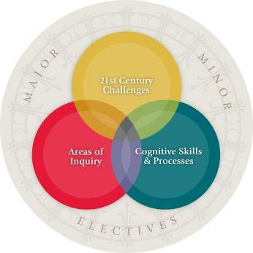
RUTGERS, THE STATE UNIVERSITY OF NEW JERSEY

School of Environmental and Biological Sciences

Department of Landscape Architecture

11:550:271 Agriculture + The Landscape

Instructor: Arianna Lindberg

Contact: a.lindberg@rutgers.edu

Office hours by appointment

Class meetings: Fridays, 12:10-3:10pm

Course Description
Agriculture is the result of direct human interaction with the land; how we manipulate the earth is a product of our culture. This course examines topics of both ecological stewardship and exploitation, and social justice and inequity as they relate to agriculture and food, with regard to urban, peri-urban, and rural settings and practices.

It is a creative and challenging time for agriculture, particularly in a built-out state like New Jersey, and also as we navigate the impacts of global climate change. This semester, we will investigate various farming typologies at different scales and in different localities. We will ask: Where does our food come from? How do human systems and natural systems intersect in agriculture? What is sustainable agriculture? What does urban agriculture mean? What is our relationship to our food system now? What are the agricultural challenges of the future? Can we feed nine billion people in an equitable manner without degrading our soil, our water, and our social fabric?

Our goal is to become more thoughtful about choices that we may now take for granted and to participate in a more conscious relationship with our food, farms, and farmers. As such, experiential learning, conversations with farmers, and a humanities-based lens provide the tools for reading a variety of urban, suburban, and rural agricultural landscapes.

Core Curriculum: Contemporary Challenges (CCD) Learning Objective
Students are able to analyze contemporary social justice issues and unbalanced social power systems.
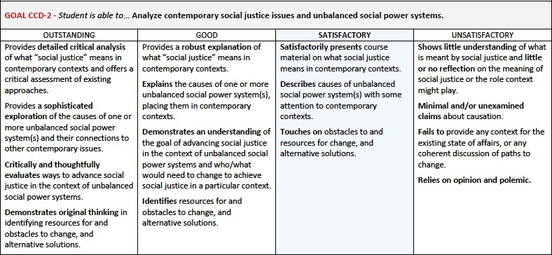

Additional Learning Objectives and Assessment
- Students gather data on agriculture as it relates to the landscape and increase their agricultural literacy (Project 1, Project 2, Readings)
- Students approach a project from a variety of scales, accentuating the experiential, human scale as well as thinking in terms of larger urban and global food systems (Project 2, Final Reflection)
- Students observe and explore ways to engage the public in issues of agricultural stewardship and sustainability (Field Trips, Panel Discussions)

SEBS DEI Statement
It is our intention that students of all backgrounds will be well served by this course. We will work to create an environment of inclusion which respects and affirms the inherent dignity, value, and uniqueness of all individuals, communities and perspectives. We are lucky to have a diverse university. Diverse voices and life experiences enhance the learning process, and we welcome students to share their personal experiences. We will not tolerate disrespectful language or behavior against any individual or group. If you feel as though you have been disrespected or treated unfairly by the instructors or any other individual please let us know. You may speak with the instructors in person, over email or report anonymously via the Office of Academic Programs. In addition, you may also report bias to the Rutgers Diversity and Inclusion initiative using this link: http://inclusion.rutgers.edu/report-bias-incident/.

Course Details
Class is more rewarding for all of us when students actively participate! I ask that you attend classroom sessions and field trips, engage in discussions, and complete/submit all assignments by the specified deadlines and following the specified guidelines. Please review the semester schedule carefully, as this document includes weekly information; Canvas Modules will be posted weekly with reminders, links, and additional information. Please stay up to speed with work and communicate with me if there are circumstances that impact attendance or completion of work.

Lectures: Lectures are intended to equip you with general knowledge about agriculture. I encourage you to take notes, ask questions, and explore topics independently to aid in synthesizing information from lectures along with various other course materials (films, readings, panels, projects, etc.) – all of which will benefit you when the time comes to write your final reflection. PDFs of PowerPoint slides will be posted following each lecture and will be available as resources/references for students for the duration of the semester.

Readings: Readings are assigned most weeks and are available in the Files folder on Canvas. For each reading you are asked to select a quote (or short passage) that is of particular interest to you and say why. Did the passage challenge what you previously thought? Did it raise more questions? Did it make you think differently about something? Did it resonate with your own experience? Responses should be approximately 5-8 sentences and posted to the associated Canvas Discussion thread. You are encouraged to review your classmates’ responses as well and engage in productive exchanges throughout the week. These posts will serve as a starting point for in-class discussions. Reading posts/responses are due no later than Thursday of each week at 11:59pm; the Discussion will “lock” at this time, and late submissions will not receive credit.

Films: Several films/documentaries will be viewed during class time over the course of the semester. Following the films, we will engage in class discussion.

Field Trips: Several field trips are planned for the semester. Any necessary travel is built into the course meeting time. Attendance is required. No assignments are associated with field trips; however, farm visits may involve some hands-on activities and may be used as reference material for your final reflection. Carpooling will be organized in advance.

Projects:
- Culinary Heritage – where in the world did this food come from?
- Food and Farming in the Time of Climate Change – examining how climate change has directly and indirectly impacted agriculture and/or how agriculture has impacted/contributed to climate change (animal farming, emissions, water use/quality, food access and security, farm labor, etc.)

Final Reflection: A short reflection essay will ask you to connect topics, theories and concepts addressed in course content (projects, lectures, readings, field trips, panels, and films) in accordance with the Contemporary Challenges Learning Outcomes.

Contact: It is important that all students are given the same updates and information. Beyond announcements made in class, I will rely on Canvas Announcements. Please check your RU email/Canvas regularly for any updates or changes!

Grading / Evaluation
Your grade will be based on:
- Synthesis of information presented through lectures, films, readings, panels, and field experiences
- Application of this information to projects throughout the semester and in the final reflection

The final grade will be based on the following percentages:
Reading responses 20%
Participation 20%
Project 1 15%
Project 2 20%
Final Exam 25%
Departmental Grading Guidelines
While the assignment of grades is ultimately the purview of the instructor, the department uses the following guideline for understanding appropriate grading in its courses:

A – Outstanding –This not only means fulfilling the requirements but impressing and going beyond the initial expectations of the project. The student has demonstrated a superior grasp of the subject matter coupled with a high degree of creative or logical expression, and strong ability to present these ideas in an organized and analytical manner.
B – Very Good – The student has demonstrated a solid grasp of the material with an ability to organize and examine the material in an organized, critical, and constructive manner. The projects and in‐class performance reveal a solid understanding of the issues and related theories or literature.
C – Acceptable –The student has shown a moderate ability to grasp concepts and theories for the class, producing work that, while basically adequate, is not in any way exceptional. This performance in class displays a basic familiarity with the relevant literature and techniques.
D – Unacceptable – The work demonstrates a minimal understanding of the fundamental nature of the material or the assignment with a performance that does not adequately examine the course material critically or constructively. Students cannot graduate from the Landscape Architecture program with 2 D’s in required 550 classes.
F – Failure – The student has demonstrated a lack of understanding or familiarity with course concepts and materials. Their performance has been inadequate. Failure is often the result of limited effort and poor attendance which may indicate that the student is not in the proper field of study.
The following scale applies:
A | 90% and above
B | 80% to 86% | B+ | 87% to 89%
C | 70% to 76% | C+ | 77% to 79%
D | 60% to 66% | D+ | 67% to 69%

Due Dates
Except for circumstances truly beyond the student’s control, all assignments are due at the dates and times specified. Projects and assignments that are incomplete on the due date should still be submitted on the date they are due in order to receive at least partial credit.

Academic Integrity
The University’s policy on Academic Integrity is available at http://academicintegrity.rutger.edu/academic-integrity- policy. The principles of academic integrity require that a student:
- Properly acknowledge and cite all use of the ideas, results, or words of others
- Properly acknowledge all contributors to a given piece of work
- Make sure that all work submitted as his or her own in a course or other academic activity is produced without the aid of impermissible materials or impermissible collaboration
- Obtain all data or results by ethical means and report them accurately without suppressing any results inconsistent with his or her interpretation or conclusions
- Treat all other students in an ethical manner, respecting their integrity and right to pursue their educational goals without interference. This requires that a student neither facilitate academic dishonesty by others nor obstruct their academic progress
- Uphold the canons of the ethical or professional code of the profession for which he or she is preparing

Adherence to these principles is necessary in order to ensure that:
- Everyone is given proper credit for his or her ideas, words, results, and other scholarly accomplishments
- All student work is fairly evaluated, and no student has an inappropriate advantage over other
- The academic and ethical development of all students is fostered
- The reputation of the University for integrity in its teaching, research, and scholarship is maintained and enhanced

Failure to uphold these principles of academic integrity threatens both the reputation of the University and the value of the degrees awarded to its students. Every member of the University community therefore bears a responsibility for ensuring that the highest standards of academic integrity are upheld.

Accommodations for Students with Disabilities
Disability Services
(848) 445-6800 / Lucy Stone Hall, Suite A145, Livingston Campus, 54 Joyce Kilmer Avenue, Piscataway, NJ 08854 / https://ods.rutgers.edu/
Rutgers University welcomes students with disabilities into all of the University's educational programs. In order to receive consideration for reasonable accommodations, a student with a disability must contact the appropriate disability services office at the campus where you are officially enrolled, participate in an intake interview, and provide documentation: https://ods.rutgers.edu/students/documentation-guidelines. If the documentation supports your request for reasonable accommodations, your campus’s disability services office will provide you with a Letter of Accommodations. Please share this letter with your instructors and discuss the accommodations with them as early in your courses as possible. To begin this process, please complete the Registration form on the ODS web site at: https://ods.rutgers.edu/students/registration-form.

Student Wellness Services
Just In Case Web App: http://codu.co/cee05e
Access helpful mental health information and resources for yourself or a friend in a mental health crisis on your smartphone or tablet and easily contact CAPS or RUPD.

Share A Concern: http://studentconduct.rutgers.edu/do-something-to-help-share-a-concern/why-share-a-concern/ There are times when people may observe a behavior and feel concerned. These concerns may be part of a larger story for a student facing challenges. Thus, it is important to Do Something and share your concerns so that the student can get assistance as soon as possible before the issues grow too large. If the concern is immediate, call 9- 1-1.

Counseling, ADAP & Psychiatric Services (CAPS)
(848) 932-7884 / 17 Senior Street, New Brunswick, NJ 08901/ www.rhscaps.rutgers.edu/
CAPS is a University mental health support service that includes counseling, alcohol and other drug assistance, and psychiatric services staffed by a team of professional within Rutgers Health services to support students’ efforts to succeed at Rutgers University. CAPS offers a variety of services that include individual therapy, group therapy and workshops, crisis intervention, referral to specialists in the community and consultation and collaboration with campus partners.

Violence Prevention & Victim Assistance (VPVA)
(848) 932-1181 / 3 Bartlett Street, New Brunswick, NJ 08901 / www.vpva.rutgers.edu/
The Office for Violence Prevention and Victim Assistance provides confidential crisis intervention, counseling, and advocacy for victims of sexual and relationship violence and stalking to students, staff, and faculty. To reach staff during office hours when the university is open or to reach an advocate after hours, call 848-932-1181.

Scarlet Listeners
(732) 247-5555 / http://www.scarletlisteners.com/
Free and confidential peer counseling and referral hotline, providing a comforting and supportive safe space.

